CLASS HEADER

Tarsiers Security Company Business Plan
NAME
Sales and Marketing Manager

A. Executive Summary 4
A1. Company Identification 4
A2. Mission of the Company 4
A3. Business Goals 4
A4. Keys to Success 4
B. Company Summary 5
B1. Industry History 5
B2. Legal Form of Ownership 5
B3. Location and Facilities 5
B4. Management Structure 5
B5. Products and Services 5
C. Market Analysis 6
C1. Target Market 6
C2. Industry Analysis 6
C3. SWOT Analysis 7
D. Market Strategy 8
D1. 4Ps 8
D2. Price List 8
D3. Promotional Strategy 8
D4. Sales Forecast 8
E. Implementation Strategy 9
E1. Overall Strategy 9
E2. Monitoring Plan 9
F. Financial Statements and Projections 10
F1. Forecasted Profit and Loss Statement 10
F2. Forecasted Balance Sheet 10
G. Financial Report 11
G1. Financial Projections 11
G2. Financial Position 11
G3. Estimated Capital/Investment Needs 11
H. References 12

Executive Summary
A1. Company Identification:
The Company's name is Tarsiers Security Company. The name is derived from a small primate animal named tarsier, commonly found in Southeast Asia. Tarsier is a unique animal because it has wider eyes that take the better part of its head (Shekelle et al., 2017). Most importantly, the nocturnal animal has some of the sharpest eyesight in the animal Kingdom, especially at night. The Company plans to manufacture a tiny but powerful security camera, two centimeters in radius, and able to see clearly in darkness and will go by the name Tarsier Security Company; abbreviated as or T.S.C. or TSC.
Tarsiers Security Company will be located in the Ashbury Complex, along Oak Street in Thompson city (Manitoba-Canada).
A2. The mission of the Company:
The Company's mission is to serve the Canadian and the global community by guaranteed property monitoring free from power interruptions.
A3. Business Goals:
To realize our mission, we plan to expand our services by going international to take advantage of globalization. We plan to open offices in Egypt (North Africa), Hong Kong (Asia), and Miami (United States). This expansion into a diversified global market will enable the company to swell its revenue potential by gaining access to a vast base of international customers. This will help should the Canadian market be hit with financial turmoil or if the market hits maturity causing earnings shrink or flatten out (Topno, 2019). Also, it will help to to lower operational costs by taking advantage of cheap labor and low operational demands in the target countries. The company also stands to improve its image internationally by operating in diverse environments.
The second goal will be to provide excellent customer service to build a profitable empire by attracting and retaining new customers to emerge as the leading players in the industry. Every customer who knocks at our door is crucial to building our business and propelling us into a brighter future. We believe that a single customer can ruin or form company pillars for prosperity. We shall indeed produce high-quality security cameras with unique features to solve the traditional problems of detectable cameras and malfunctions during power blackouts. Apart from such an advantage, we yarn to rely on customer referrals to enable us to prosper. For better service delivery, we shall recruit the most competent employees in respective fields to guarantee efficiency in service delivery in all dockets.
A4. Keys to Success:
One of our primary keys to success will be differentiating our products and services from industry players. Our product will be our selling point and our company ambassador due to its uniqueness. In brief, Tarsier Security Camera will be a digital camera that will be unnoticeable but accompanied by the false type. It will also have a powerful camera that can run for eight hours without relying on a power supply.
Another key to our success will be producing high-quality cameras that will be sold at relatively affordable prices. Such a strategy is expected to sway customers our way due to affordability and guaranteed quality. We expect the relatively lower prices to increase sales and enable the company to garner customer loyalty.
Lastly, our anchorage will be vested in the quality of our employees. Quality products and quality services can only be met via the hiring of an exemplary team. From such a standpoint, we plan to hire talented employees in all segments. One advantage that we have is that the Company's Chief Executive Officer is an electrical engineer with a degree in business management. The Company expects to handsomely remunerate our employees through quality-based incentives while rewarding out-of-the-box creativity. Our management style will be democratic and open to enhance employee development via training and departmental collaborations.
- Company Summary
B1. Industry History:
Commonly referred to as CCTV (Closed Circuit Television), security cameras are commonplace in Canada dating back to 1990 when the government initiated open-street camera surveillance in Sherbrooke (Quebec) aimed at taming crime and monitoring traffic (Piza, 2021). The cameras were initially used in the private sector in entertainment venues and affluent residences for security purposes. The significant rise in the use of CCTV in Canada was influenced by the culture of the U.K. to install CCTV along open streets. The success story of the U.K. to fight crime with such systems fueled the need for CCTV around the world, including Canada. When images of a CCTV in a Merseyside mall identified the killers of Jamie Bulger in 1993, the government increased funding of CCTV projects to cover all significant streets and busy public places. Most projects gained momentum in 2000 to fight the high instances of violent crimes. Toronto's CCTV projects were influenced by the shooting of Jane Creba in 2005 on boxing day (Piza, 2021). Other municipalities started using temporal CCTV during functions.
By 2007, at least 15 cities had CCTV on their streets, while 17 municipalities were considering such projects. The projects sometimes met public resistance due to privacy issues and controversies in their court usage. The fear of crime fueled by a rise in terrorism justified the installation of security cameras in both private and public spaces. Initially, Canada consulted the U.K. both for purchasing of CCTVs and their schemes. The higher demand attracted CCTV camera companies to Canada in the late 2000s, one of the first being the Avigilon Company that Fernandez Boris founded in 2004 in Vancouver (Piza, 2021), followed shortly by Vicon, Dahua technologies, Milestone, N.V.T. Phybridege, Videotec, 3x Logic, and 3D Eye.
B2. Legal Form of Ownership:
Tarsier Security Camera company will be registered as a limited partnership company. Canadian business law (Act, R. S.O. 1990, c. L. 16) defines a limited partnership as a "business entity that has both general and limited partners who join hands to venture into a specific business" (Chechurina & Grin, 2020, p. 67). Limited partners who take up active roles become liable to the business too. Steve Fortunes, the founder of the company, will partner with his longer-term business associate named Alpha Carlos. Carlos will be Fortune's co-founder, and the two will be the top leaders of the Company, with Fortune as the Chief Executive Officer and Carlos as the Assistant Chief Executive. The two shall determine how to make decisions that matter to the Company and structure the most appropriate ways of sharing losses and profits. Another discussion of concern is about conflict resolution. Both Carlos and Fortune shall discuss the mechanisms that can be used to address conflicts that may arise in line with company operations. Another vital element to be covered is the mechanism of resolving the business or altering the general structure of the company. All such details shall be presented to the business registrar of the province.
B3. Location and Facilities:
The company's premises will be located in the Ashbury Complex along Oak Street in Thompson city (Manitoba-Canada). We have entered leasing negotiations with StepUp Investment company that owns the building. The building is suitable for our company requirements as it has spacious rooms that can be subdivided to meet our needs. It has two vacant halls that are 275 square meters each (roughly 3,000 square feet) and several other attached rooms that total 100 square meters (roughly 1,075 square feet). The enormous spacious halls can be used as camera manufacturing centers with Chief Engineer's office. The other rooms can be used for management and marketing functions. The building has reliable sources of water and power with modern restrooms and kitchen as well as easy-to-clean floors. Another advantage is that its main entrance faces Oak Street and is conveniently located for easy transportation and access and is only 15 minutes from Thompson Airport. This will enable easy transportation and receiving/shipping of time-sensitive orders as well as human resources travels.
The camera project requires various facilities for the smooth running of its operations. One of them is furniture. We shall require office tables, chairs, and cabinets. Also, there is a need to have lab tables and raised chairs. The expansive halls don't have an air conditioner; the company will have to buy one. Also, the facility lacks adequate parking, so we are researching alternative spaces and shuttles to manage anticipated employee parking. Additionally, we may have the need for an alternative source of power to address the occurrences of power blackouts. Having a standby generator will serve us well as it will ensure a steady power supply to avoid unnecessary business disruptions, especially at the manufacturing lab. Another vital consideration is the internet and company electronics. There is a need for a stable internet connection to serve both the offices and the lab operations.
B4. Management Structure:
The management team at TSC understands the value of a well-structured team with skills and motivation in line with the realization of company goals and mission. We plan to strictly target the most talented individuals to build a robust team ready to live up to the expectations spelled out in our mission and goals. Based on such facts, our management team, led by Steven Fortune (the C.E.O.), will comprise of the Chief Executive Officer, Assistant Chief Executive Officer, Human Resource Manager, Chief Financial Officer, Sales Agents, Chief Camera Engineer and Technician, Customer Care Officer and Sales and Marketing Manager. The Sssistant C.E.O. will assist the C.E.O. in the running of the Company with the Human Resource Manager dealing will issue related to the labor force. The Chief Engineer will assist the Human Resource Manager in the smooth running of the engineering department while the Sales and Marketing Manager will be in charge of the marketing team. The Chief Accountant will be responsible for addressing company financial matters. Their responsibilities can be broken down as follows;
Chief Executive Officer
- Enhance Company's effective management via recruiting, orienting, selecting, motivating employees and managers, determining policies after consultation, and delegating tasks
- Responsible for determining the direction of the Company
- Responsible for determining product and service prices, signing deals, documents, checks, and other relevant connections on behalf of the Company
- He will strive to implement the vision, goals, and mission of Tarsier Security Camera company
Assistant Chief Executive Officer
The officer will assist the C.E.O. in the smooth running of the Company as determined and directed by the C.E.O. Some of the responsibilities for the Assistant shall include helping the C.E.O. to;
- Develop and implement the general strategy of the Company
- Sign documents on behalf of the C.E.O.
- Evaluate the progress and the success of the Company
- Ensure that the set prices and the delegated duties are well-executed
The Human Resource Manager (HR)
- Account for the evaluation, training, and assessment of the company employees
- Orientation of new team members with regards to the company's mission, goals, relations, and any other relevant aspects of company culture and policies
- Perform administrative tasks including defining job positions and managing recruitment processes
- Hold meetings to revisit the effectiveness of human resource policies
Chief Financial Officer
- Responsible for developing budgets, preparing and providing financial reports and analysis
- Perform risk analysis and financial forecasting
- Acts as an internal auditor and financial advisor
- Ensure that the company is tax-compliant
- Perform financial transactions on behalf of T.S.C.
Sales and Marketing Manager
- Recruits, leads, and motivates the sales team
- Designs and executes sales campaigns
- Write winning proposals and negotiate charges on behalf of T.S.C.
- Determines business opportunities and assigns major accounts
- Supervise and advocate for the needs of our clients to ensure future product development is in line with client needs and expectations
- Determines ways of escalating sales and develops mechanisms of swelling product and service sales
Chief Camera Engineer and Technician
- Responsible for the designing, manufacture, repair, and installation of Tarsier Security Camera systems
- Conducts training, offer consultancy services, and chooses the best software and camera specifications
- Oversee the development of work schedules in the manufacturing labs
- Supervises the manufacturing processes of the cameras
Customer Care Officer
- Over-see the deployment and management of the customer services team
- Manages client escalation issues to resolution
- Receives and distributes company information to current customers
- Provides information about product specifications, warranties, delivery options, and maintenance procedures.
- Supplies valid information to customers concerning promotions and offers
Sales Agents
- Participate in sales campaigns
- Promote products in the field by educating customers on product specifications and aligning client needs with our current product line
- Help in generating leads and gaining new clients and contracts
Management Structure
C.E.O.

ASSISTANT CEO

HUMAN RESOURCE MANAGER

SALES & MARKETING MANAGER
CHIEF CAMERA ENGINEER & TECHNICIAN

SALES AGENTS
CUSTOMER CARE OFFICER

B5. Products and Services:
The company's TSC1 – our first version camera system - will be comprised of a camera(s) that are 2cms in diameter as well as a base unit and will have the following features:
- Record videos through motion detection using a nanny cam style sensor
- The camera is connected to a powerful battery that runs for seven hours without external power
- Its sensor will allow it to have a strong night vision that will illuminate objects and/or people for easy identification
- The TSC1 will have infrared illumination to prevent it from glowing in the dark
- The camera will have a feature that will enable it to sense smoke and signal the base unit to contact fire department
- The base unit will come with a decoder that can store images of chosen people, for instance, the managerial team, security, etc. When placed in sensitive areas the unit will match the images of approved personnel with current traffic. If any unauthorized person/image is detected, the unit will raise the alarm and display the video and verbal conversation of the intruder via web or app interface. Such a device will be important in sensitive areas, such as banks and high-end residential areas.
Apart from our Tarsier Camera line, we shall offer camera servicing and installation services for digital security cameras in Canada and our international branches in Egypt, Hong Kong, and Miami. We shall be offering free installation services to individuals or companies that buy our cameras and are located with a radius of 20 miles of our facility, satellite offices and/or installation partners. Apart from installation services, the Company will be offering security camera video analysis at affordable fees and free of charge for our hardware clients. We are also researching the viability of offering virtual training classes in security camera installation and maintenance; the digital era has led to more interest in learning the art and science behind security cameras and we feel there’s an opportunity to capitalize on this interest.
- Market Analysis
C1. Target Market:
Tarsier Security Company plans to sell its products mainly to the Canadian market before going international. Our home city of Thompson, MB is among cities with high rate of crime with several local incentive and city initiatives targeted at digital surveillance. This means that the city will form our primary initial market due to the high demand by both the government to install security cameras along the streets and in public venues. Our extensive research has identified several other cities that are currently struggling with high rates of crime. These cities include; Hamilton with a crime score of 53.36, Regina (53.8), Brampton (67.2), Winnipeg (65.6), North Bay (83.4), and Surrey (87.2), among others. Many business owners in these cities cite vandalism and break-ins as their highest cost of opperations. The government is also worried about the high rates of car hijacking and assault in the streets (Cesaroni, & Doob, 2020). For instance, Lethbridge records over 100 cases of car hijackings annually. Residents in Red Deer affirm that walking alone in the streets is dangerous, even during the daytime. More shopping malls and hotels are coming up, high flow of foreign direct investment (FDI) in retail and construction sectors, high rates of cyber-attacks on government agencies, including private firms, are among factors that fuel demand for the installation of new, and expansion of existing, security camera systems.
The government plans to spend $179 million to improve cyber security via modern digital connections (Cesaroni & Doob, 2020). Also, most businesses and residential homes have analog CCTV systems; hence, there is a higher demand for upgrading to the new digital I.P. systems or installing new systems all together. Another notable statistic is that the government has rolled out many projects that require CCTVs. They include the Hi-Rise Residential Complex in Toronto, Burnaby Hospital Redevelopment Phase 1 in British Columbia, and expansion of transportation facilities including expanding airport terminals like Naujaat, Chester Inlet, and Kugluktut (Kamali et al., 2021). The government has multiple mega tenders or RFPs (request for proposal) for CCTV installation and maintenance, with Ontario expanding its coverage of CCTV. Other areas in need of CCTV include commercial offices, the industrial sector, banking, educational, and healthcare institutions. Additionally, number of homeowners has increased due to the increase in Canada's middle and high-income earners. The homeownership rate has improved from 66.2% in 2018 to 68.27% in 2019 (Allen et al., 2020). In the public sector, the company will mainly target individuals between 25 and 40 years who make up 40% of Canada's middle class.
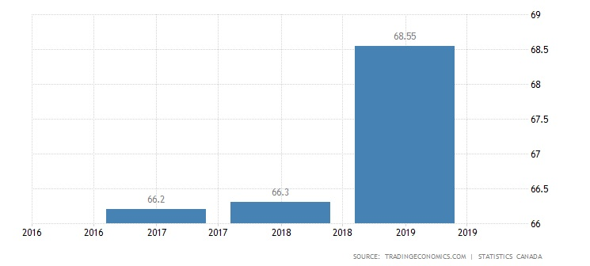
NOTE: What is this graph? There’s no title or explanation.
The many CCTVs in Canada., it is expected that the need for maintenance and consultancy will be high.
C2. Industry Analysis:
In Canada, security cameras, security cameras, and alarm installers fall under the Security Service Industry. Most of the companies under this docket also offer installation and maintenance services for security cameras. Canada has over 200 registered companies that manufacture such cameras, including ACTI, Sony, and Axis. The industry's growth is expected to be positive because of an increase in the security camera demand by both the public and the private sector. Also, many of the old security devices and systems need an overhaul while the government has several surveillance projects to roll out. They include upgrading all the security details of the airports and highways. The industry is expected to growth of 11.4% by 2025 from $45.5 billion to $74.6 billion. These years, the security segment expects $341 million. The average earnings for each Smart Home will attract $247 annually (Norris & Armstrong, 2020). The industry has a bright future due to increased homeowners, the banking sector, and government projects.

S (Strengths)  1. Strategic location along Oak Street  2. Exceptional camera details  3. Excellent customer care culture | W (Weaknesses)  1. The Company is new in the CCTV security industry  2. Finances  3. Dependence on middle and upper-class strata
O (Opportunities)  1. High crime rates in many cities throughout Canada  2. Our location along Oak – with regard to securing business and employees in Thompson  3. High number of analog CCTV in need of upgrade or replacement | T (Threats)  1. Unfavorable national policies  2. Imitation of our technology  3. Competition from established firms
C3. SWOT Analysis:

Our significant opportunities include high crime rates in Thompson and other cities in Canada, especially those in the prairies. Many cities in Canada struggle with crime issues including North Battleford, Hamilton, Regina, Winnipeg, and others. Such areas will create a reliable market for our TSC1 and installation services. Our strategic location along the busy Oak Street and close to the Thompson airport will make transportation of goods and human resources easier. The street has many businesses and government offices that will be our potential immediate target market. Additionally, the high number of analog CCTVs means that the owners will need an upgrade or replace their current security systems.
Our unique cameras capable of detecting smoke and identifying unauthorized individuals are expected to differentiate us from our competitors. Also, our quality customer service will enable us to attract and retain customers and create a positive business image.
Our significant weaknesses are that we are new in the CCTV market hence we might face both managerial and logistics problems. We also may lack the public identity needed secure some of the more substantial government accounts. Financial problems might sabotage our ambition to hire talented individuals and fail to purchase all the needed facilities and equipment. Additionally, depending on the middle and upper-classes will limit our customer base, eliminating the lower class, often including the elderly, from our equation.
Some of the threats include unfavorable governmental policies, for example, high taxation and stringent registration and regulation of the industry that may limit our operations. More established competitors might imitate our camera model neutralizing our immediate competitive advantage. Lastly, we might fail to penetrate the market due to high competition from already established firms with a vast customer base and public trust.

D. Market Strategy
D1. 4Ps:
Marketing mix forms the foundation of a business. It entails a set of marketing tools that a company employs to chase its marketing goals (Chen, 2018). T.S.C.'s 4 Ps are as below.

Product - Our product mix encompasses services and goods related to Security, Security Cameras, and the training, installation, servicing, and maintenance of those cameras. For a start, our main product is TSC1 which will serve as a brand ambassador before we gain roots to diversify our products and services. Our camera shall have a warranty of two years. In a shorter description, the TSC1 is a High-Definition camera that, when combined with its base unit, uses Internet Protocol (I.P.) to enable remote camera control and monitoring. The camera uses 460 lines in its coverage enabling it to see clearly in darkness. The tiny wireless camera comes in varieties of colors. It uses a network video recorder (part of its base unit) and has a glass cover making it weather-resistant allowing it to be deployed either indoors or outdoors. Our services include installing the whole CCTV system and upgrading the analog systems to I.P. We will also be offering repair services for malfunctioning systems as well as consultancy services regarding installation, camera choice, service programs and monitoring.

Price - The company plans to use a competitive pricing strategy by charging relatively lower prices than our competitors. The strategy aims at enabling the company to penetrate the market (Zhang, 2020) with lower prices to overcome our deficiency as a new-comer to the market. Overcharging or undercharging will be avoided in the provision of installation and servicing of the security devices. We shall then switch to value-based pricing after our customers and the general market acknowledges the value of our products and services we offer. This will enable us to increase profitability and win customer loyalty. For convenience, our customers will be able to choose from multiple payment options that include bank transfers, mobile money, cash, online banking, and checks. The company plans to give discounts on our services (installation and maintenance of CCTV systems) to those who buy our TSC1 system (See the price list on the next page). The discounts will be offered based on the radius from our retail stores.

Place - Tarsier Security Company will use various destinations to distribute and deliver our products across Canada to our target customers. For easy access by our customers, we have carried out extensive geographical research, determined various suitable locations in significant towns, and made down payments on office locations. Our retail stores will be located at Commercial Tower (first floor-room 23), Freedom House (ground floor-room 13) in Winnipeg city, Vancouver Plaza (third floor-room 7) in North Bay, and Fista Business Center (ground floor-room 3) in Hamilton. We shall also have a significant store in our main facility on Oak Street where we will manage out our direct selling. We have also partnered with various authorized retailers and installers to sell our products. They include all outlets of Hamilton Technologies as well as Amazon. In addition our physical products as well as our trainings will be available for purchase through our website and social media outlets.

Promotion— We plan to carry out direct selling out our main outlets. Our sales team will also hunt for potential clients for our products and services through referral and direct sales. Additionally, our first customers will be given various gifts, including our printed T-shirts, pens, and yard signs, while being encouraged to spread the gospel about our products and services.
More customers will be reached and won via the use of introductory letters, post cards and direct email campaigns. The letters and post cards will be sent to organizations, households, innovation magazines and also distributed in innovation seminars. Our sales teams will also be attending expos to market our services and products, especially the TSC1 System and its functionality. A short video showcasing the TSC1 will be shown on our website to boost publicity. Also, our technicians will be posting the services they offer to our website and social media pages twice per week. The company will utilize digital platforms, for instance, Facebook, Twitter, and Instagram, to leverage our services and products. We expect that the uniqueness of the TSC1 and its added feature of detecting smoke and matching images will differentiate it from other cameras on the market. To add, we plan to use events attended by influencers to promote our products and services.

D2. Price List:
Tarsier Security Camera Price List
Product |  | Services
TSC1 System |  | Security Camera consultancy
One item | C$. 230 | Security Camera Installation | -Free installation of complete TSC1 System  -C$. 1250 within a 20km radius  -At most, C$ 1450 beyond 21 km.
Whole set to include 6 TSC1 cameras and a TSC1 System Base | C$. 2000 | CCTV repair | -Estimated at C$ 50
Whole set to include 6 TSC1 cameras and a TSC1 System Base | C$. 2000 | CCTV maintenance | -Free for TSC1 System within 30kms  -Estimated at C$ 500 for the whole system  -Free for TSC1 Systems for the first eight months
Whole set to include 6 TSC1 cameras and a TSC1 System Base | C$. 2000 | CCTV Upgrade | - C$ 2000 for the whole system  - C$ 500 if replaced with TSC1 Cameras

D3. Promotional Strategy:
It is sometimes helpful to spend and promote your product to attract more customers, appreciate your current customers, and bond with the immediate community. The company shall use a hockey tournament to bring people together and advertise our product and services. The Human Resource Manager shall meet with the Sales and Marketing Manager on November 14, 2022, to discuss the expenses involved. They’ll organize and print 100 company T-shirts, buy 10 Maharaja hockey sticks to be awarded to the best players, and book a public address system. The Customer Care Officer will be required to book a venue - probably the Municipal Complex – no later than December 15th. We shall then communicate about the event via the CTV media, our website, and our social media outlets. After acquiring printed T-shirts, a public address system, hockey sticks, and the venue, we shall communicate the exact date of the event. If things go as planned, we want to hold the event on February 15, 2022. All staff members will attend, allowing us to introduce ourselves to the public. The event will be presided over by the Sales and Marketing Manager and, ideally, the town Mayor. Winners will be appreciated by monetary rewards, T-Shirts, hockey sticks, and our sample TSC1 Cameras

D4. Sales Forecast:
We are optimistic that the business model will yield with time as we continue expanding in the CCTV and security business. Our anticipated monthly sales forecast is below:
Items | Dec  2021 | Jan  2022 | Feb  2022 | Mar  2022 | Apri  2022 | May  2022 | June  2022 | July  2022 | Aug  2022 | Sep  2022 | Oct  2022 | Nov  2022 | Total in  “000” C$
T.S.C. Camera | 50 | 50 | 52 | 45 | 43 | 52 | 60 | 56 | 57 | 57 | 56 | 60 | 595
CCTV Repair | 35 | 32 | 35 | 36 | 34 | 30 | 32 | 36 | 32 | 36 | 32 | 36 | 406
CCTV Upgrade | 35 | 31 | 31 | 32 | 22 | 23 | 27 | 26 | 21 | 24 | 24 | 21 | 317
CCTV Installation | 76 | 73 | 78 | 71 | 73 | 77 | 79 | 75 | 80 | 79 | 76 | 78 | 919
CCTV Maintenance | 20 | 23 | 21 | 23 | 21 | 23 | 25 | 26 | 20 | 24 | 24 | 26 | 273

NOTE: The chart above is too hard to read. It needs to be split or maybe turned landscape so that the information is legible.
We expect the year 2022 to peak due to the subdued COVID-19 pandemic. The economy is expected to open up and thrive once again. The company is expected to benefit more from CCTV installation services that will be rolled out beginning March 2022. The sales for T.S.C. will also rise from March due to installation projects and growth in the construction sector. Most businesses and residential areas will not be left behind. They are also expected to upgrade to the digital I.P. cameras, allowing us to sell our TSC1 and also take part in the upgrading exercise.
Note: The above paragraph is very choppy and doesn’t make much sense

E. Implementation Strategy

E1. Overall Strategy:
We plan to communicate early about launching our product and services that will take place on December 4, 2021. Our communication will be via Facebook and local Television stations. They include but are not limited to Northern Access Network, Brandon TV, and Dauphin. The paid T.V. adverts will begin on November 12th. We shall also communicate via our Facebook page about our products, functionality, location, and any other relevant adjustments. Before the launch, we plan to contact at least three influencers and one of the local T.V. stations to broadcast the launch for two hours. The main goal for launching our product and services is to showcase their quality and also practically describe how the products function. On December 3rd, the staff will carry out a roadshow around Thompson Town, and distribute fliers announcing The launching will take place outside our premises and broadcasted via CTV. It will be a mini-celebration marked with music, food, and speeches from the staff and influencers. Free samples will be given to a few guests too.

E2. Monitoring Plan:
After successfully launching our products and services, we shall set aside funds to meet the necessary adjustments. Our development team shall come up with extra time to respond to reviews tabled by our potential customers. We shall delve our energy into making the necessary adjustments to meet the desired quality. Our customer care desk will be fully functional to address any relevant aspects of the Company and relay the information to other departments to implement the necessary actions.
F. Financial Projection: 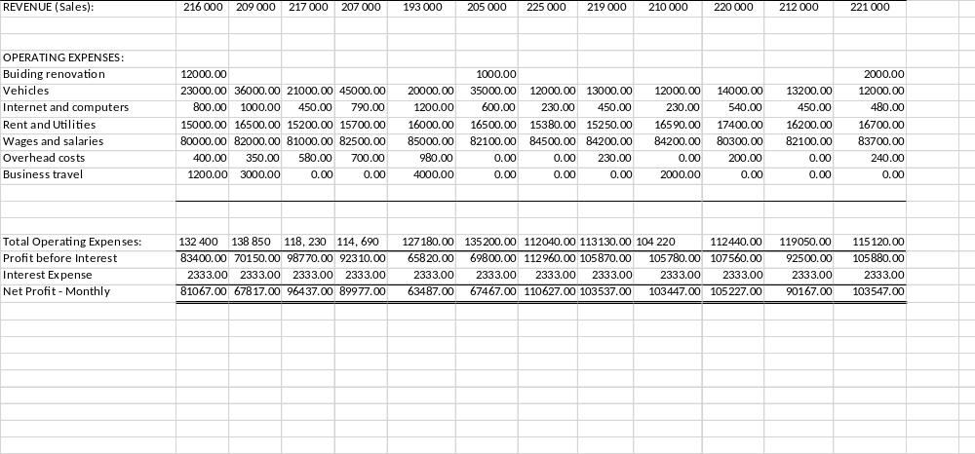

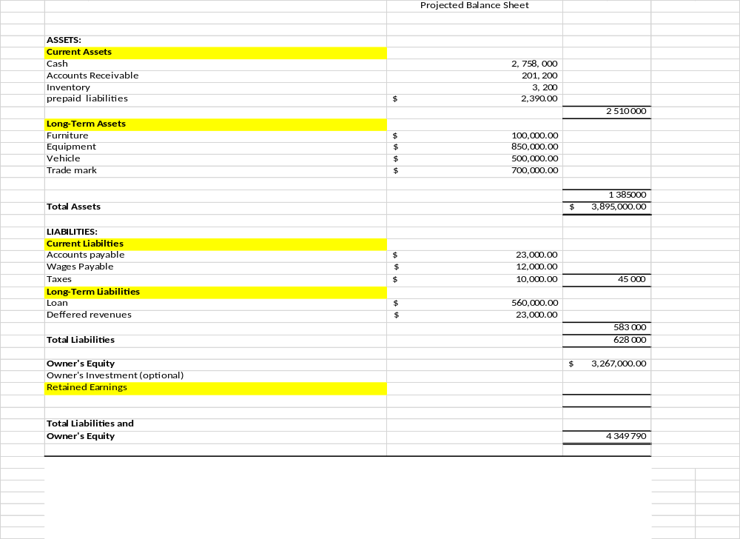

G. Financial Report
G1. Financial Projections: Summarize the financial projections and the assumptions used in estimating the financial statements.
The Company's overall performance was above the expected revenue in the first three months. After several months of navigating through the industry, the management projected to endure a dry spell of losses before gaining foot. In the first month, legal expenses and building renovation ate into the Company's profits. The Company's financial health is expected to be cushioned by installation services, the sale of Tarsier Security Cameras, and the upgrading of Closed-Circuit Television systems to I.P. systems. Registering an owner's equity of C$ 3 267 000 in the first year keeps the Company in a position to prosper further in the future. It will have enough funds to increase employee salaries and expand internationally, as stated in its goals. If other factors remain constant, the Company will go international as planned in the coming seven years.
G2. Financial Position:
The details indicated by the end-year results are valid testimony that the Company shall survive the financial storms associated with industry newcomers and stiff competition from the already established firms. Suppose the Company gradually switches to its value-based pricing system soon. In that case, it is likely to overtake most industry players who fail to innovate by depending on their traditional models. The Company presumably recorded total assets of C$ 3 895 000 and total liabilities of C$ 628 000 at the end of 2022. The difference is an indicator of the healthy financial status of Tarsier Security Company. However, there is a need for the Company to carry out the vigorous promotion of the T.S.C. camera to make it the brand image. It registered lower returns compared to services that the Company considered secondary. The lower prices charged on the product might send a wrong signal to potential customers by perceiving the product as of lower quality. Another key takeaway is the ability of the Company to repay its loan that has a five-interest loan. T.S.C. managed to pay back the minimum C$ 2333.33 every month, indicating that the Company could acquire a larger loan to make other advancements. A close look at the expenses reveals that the Company spends a lot on rent. It will be prudent for the Company to gain financial ability with speed to buy its premises or land to construct its premises. The plan will reduce expenses in the long run. The average profit of C$ 87 000 is a positive gesture writing home. At the start, it reveals the potentiality of doing even better in the future.
G3. Estimated Capital/Investment Needs:
The Company should consider buying a car that can be used for business travels involving shorter distances. Depending on public transport has many shortfalls like lateness. Also, it is prudent that the Company buys its premises to avoid paying rent.

H. References
Allen, J., Grieder, T., Peterson, B., & Roberts, T. (2020). The impact of macroprudential housing finance tools in Canada. Journal of Financial Intermediation, 42, 100761.
Cesaroni, C., & Doob, A. N. (2020). Responding to youth crime in Canada. University of Toronto Press.
Chechurina, M. N., & Grin, A. A. (2020, July). Public-private partnership in the management of ports of the world. In I.O.P. Conference Series: Earth and Environmental Science (Vol. 539, No. 1, p. 012144). I.O.P. Publishing.
Kamali, M., Hewage, K., & Sadiq, R. (2021). Conventional versus modular construction methods: A comparative cradle-to-gate L.C.A. for residential buildings. Energy and Buildings, 204, 109479.
Norris, C., & Armstrong, G. (2020). The maximum surveillance society: The rise of CCTV. Routledge.
Piza, E. L. (2021). The history, policy implications, and knowledge gaps of the CCTV literature: Insights for the development of body-worn video camera research. International Criminal Justice Review, 31(3), 304-324.
Shekelle¹, M., Groves, C. P., Maryanto, I., & Mittermeier, R. A. (2017). Two new tarsier species (Tarsiidae, Primates) and the biogeography of Sulawesi, Indonesia. Primate Conservation, 31, 61-69.
Topno, N. (2019). Globalization Impact on the International Business Development: The Tata Motors Case. МЕНЕДЖМЕНТ И МАРКЕТИНГ: ВЫЗОВЫ ХХI ВЕКА, 218.
Zhang, Z. (2020). Competitive Pricing Strategies for Software and SaaS Products. Information & Management, 57(8), 103367.

